**Installation of Oracle Database 10g:**

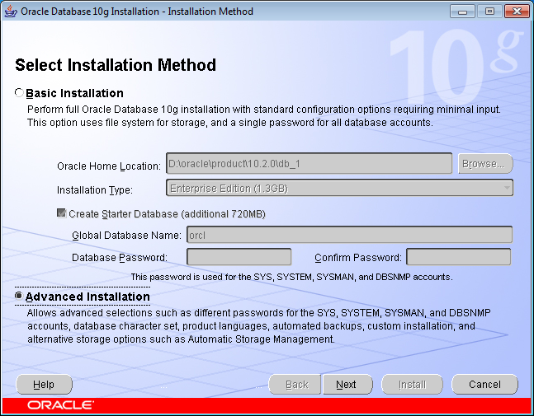

Select “**Advanced Installation**” & Click “**Next**” Button.

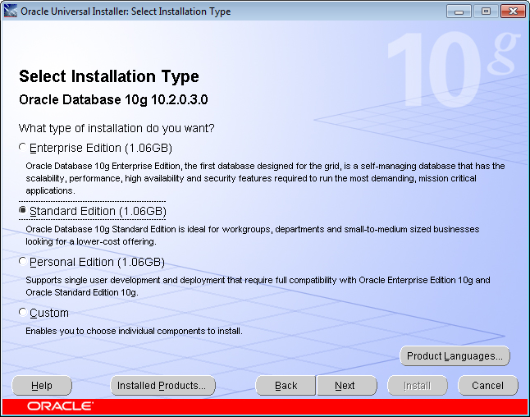

Select “**Standard Edition (1.06 GB)**” & Click “**Next**”

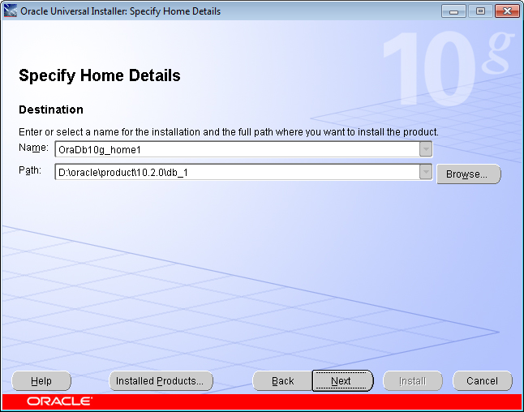

Click “**Next**”

***Note***: Its is recommended to install in other than **C** Drive (Bootable Drive).

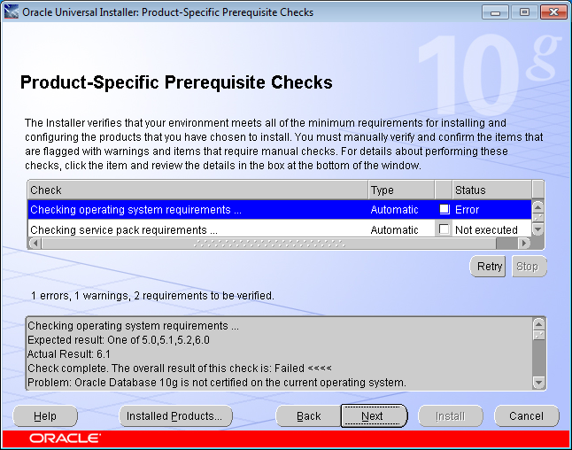

Click on “**Error**” checkbox thrice. Click “**Next”.**

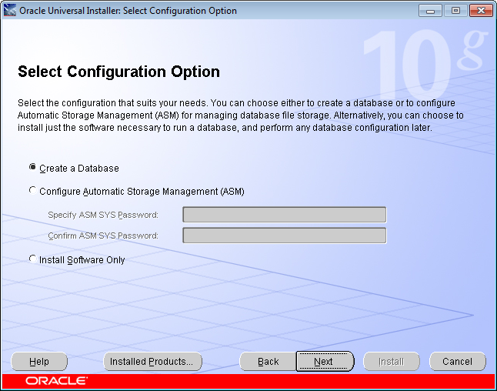

Click “**Next**”

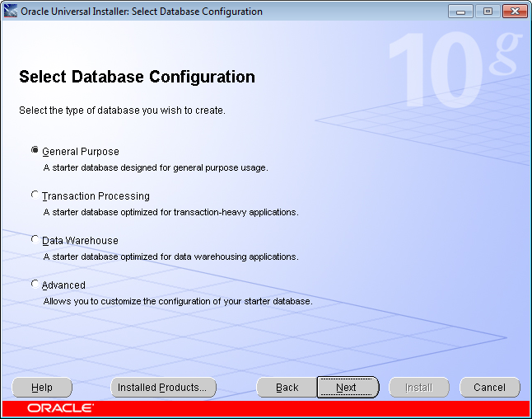

Click “**Next**”

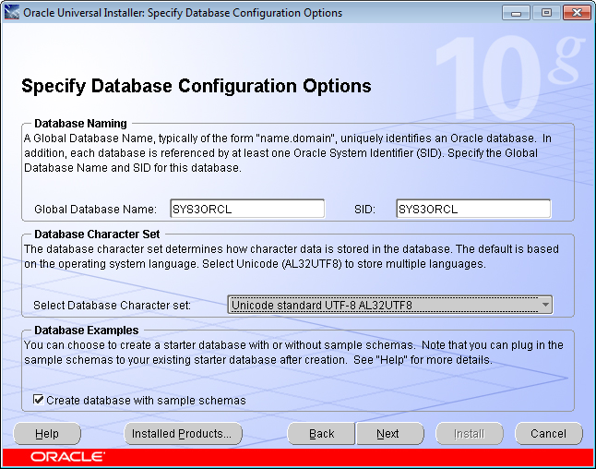

Enter the “**Host Name**” of the Computer followed by any Character in the Option “**Global Database Name**” (Easy to Remember). However, We can give any Name to Global Database Name.

Here “**SYS3**” is the Host Name & “**ORCL**” is any Character.

Change the “**Select Database Character Set**” to “**Unicode Standard UTF-8 AL32UTF8**”.

Select the “**Create Database with Sample Schemas**” checkbox.

Click “**Next**”.

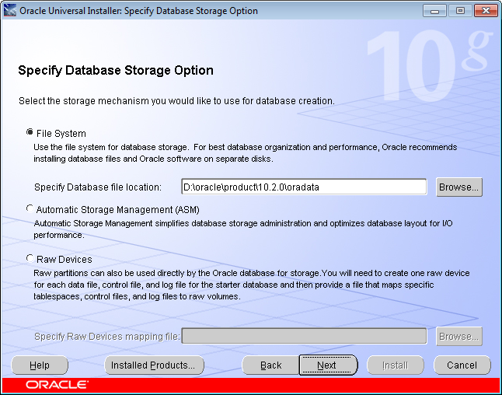

Click “**Next**”

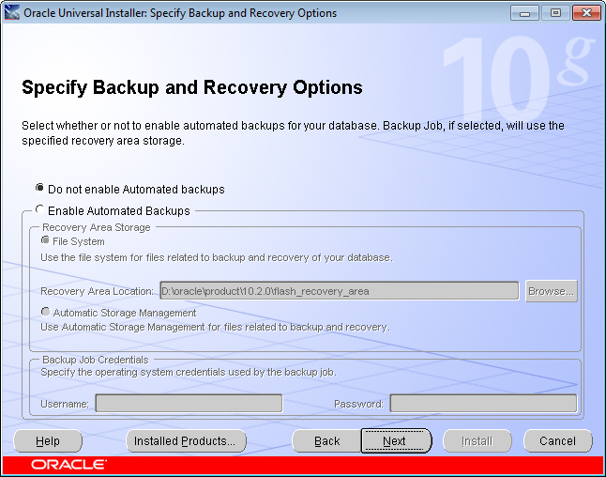

Click “**Next**”

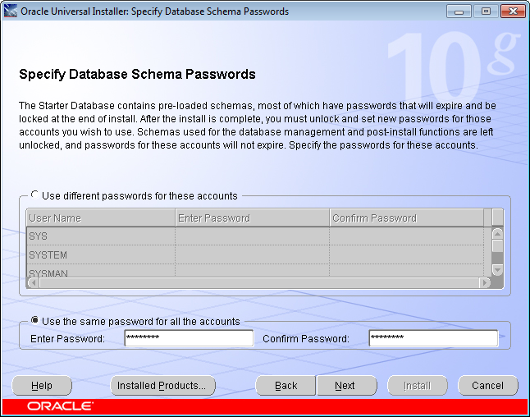

Select “**Use the Same Password for all the Accounts**” & enter the Desired Password & Click “**Next**”.

***Note:*** This is the Global Database Name Password.

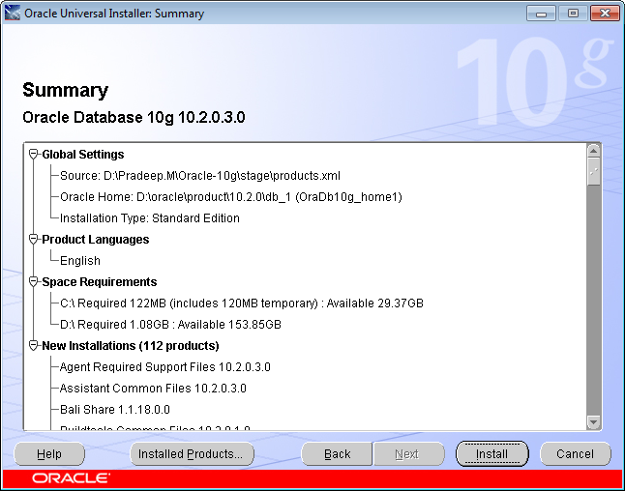

Click “**Install**” to begin Installation.

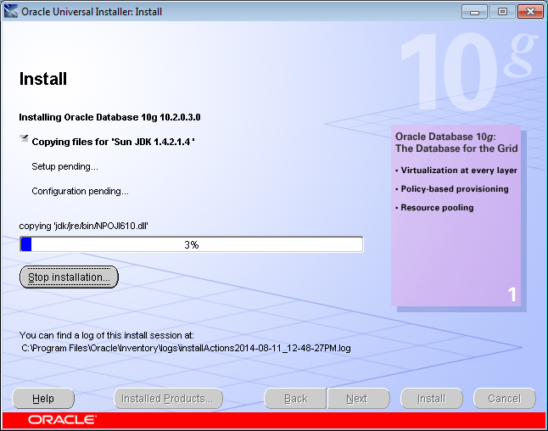

Installation Begins.

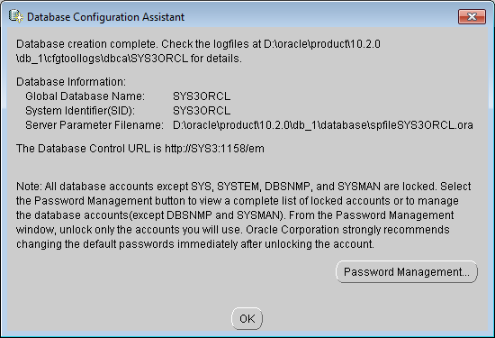

Click “**OK**” to finish Installation.

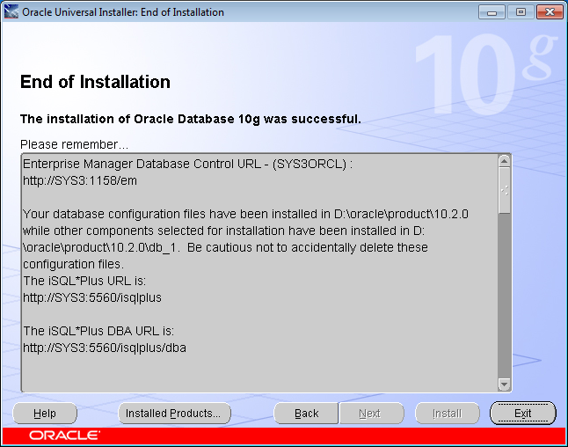

Copy the Last URL <http://SYS3:5560/isqlplus/dba> & paste it in the any of the available **Web Browser**.

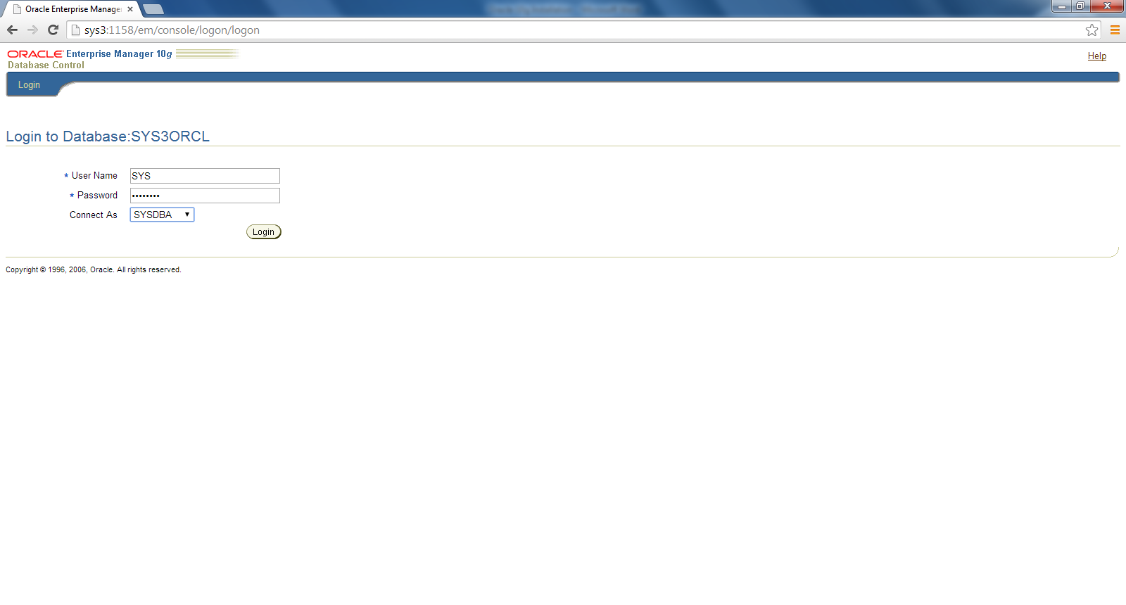

Enter “**User Name**”, “**Password**” & select “Connect As” as “SYSDBA”.

Click “**Login**”.

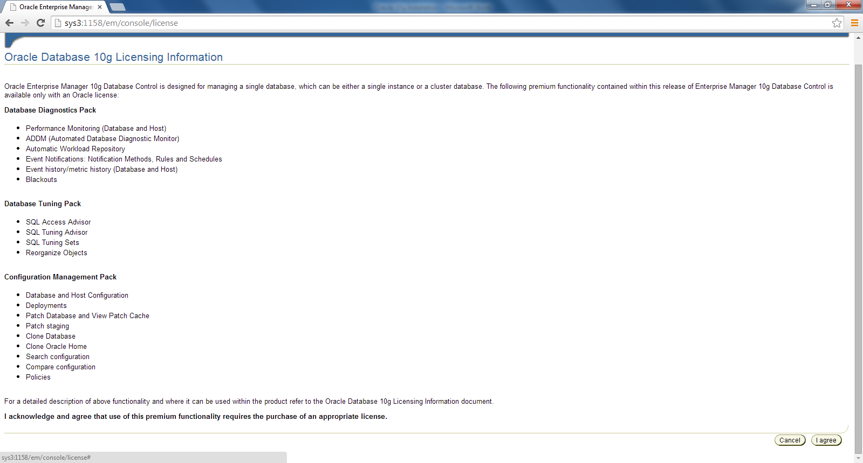

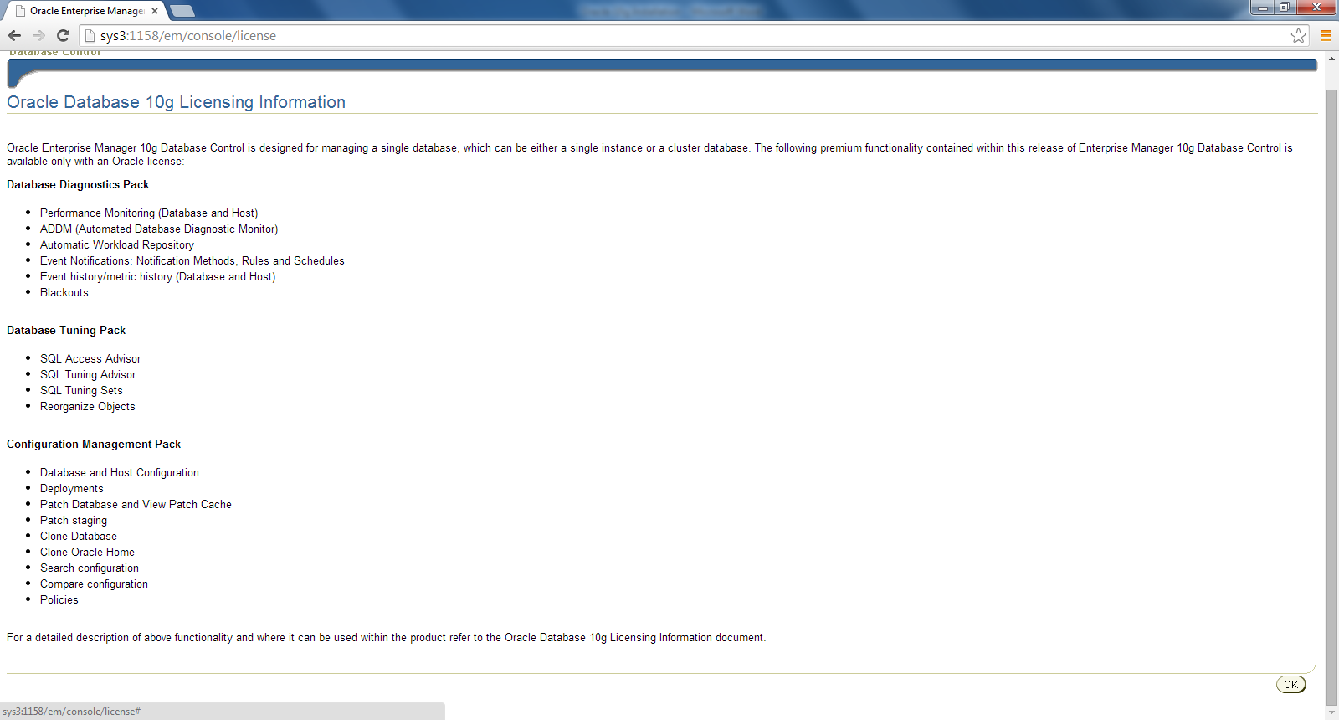

Close the Web Browser.

There are 2 ways to view the Database:

1. CLI
2. GUI
3. CMD:

Open “**cmd**”,

type “**sqlplus**” & Press “**Enter Button**” 🡪 Checking if installation is proper.

Enter User-Name: **sys as sysdba**

Enter Password: **<<Password entered during installation>>**

Enters SQL shell.

1. GUI:

Install “Quest_Toad_9.7.0.51”

**Uninstallation of Oracle Database 10g**

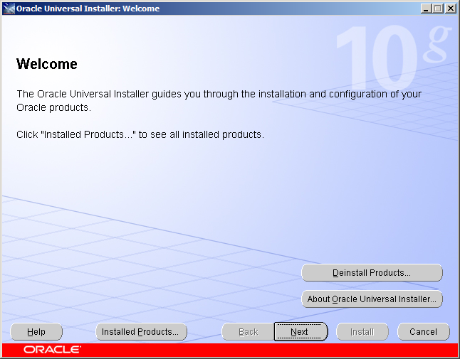

Goto “**Oracle 10g**” present in “**Start Menu**”

Select “**Deinstall Products**”

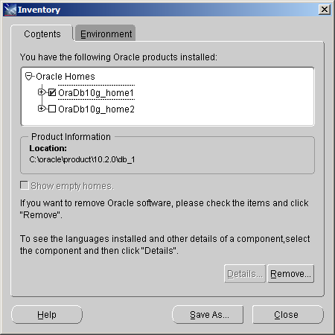

Select “**OraDb10g_home1**” checkbox & Click on “**Remove**” Button.

Uninstallation Process takes place.

Once the Uninstallation is done, remove the registration file from “**regedit**”, in order to remove “**Oracle 10g”** completely. Run **“regedit”**.

**Delete the following keys if it exits after the un-installation.**

* HKEY_CURRENT_USER\SOFTWARE\ORACLE
* HKEY_LOCAL_MACHINE\SOFTWARE\ORACLE
* HKEY_LOCAL_MACHINE\SYSTEM\CurrentControlSet\Services\OracleDBConsole
* HKEY_LOCAL_MACHINE\SYSTEM\CurrentControlSet\Services\Oracle10g_home
* HKEY_LOCAL_MACHINE\SYSTEM\CurrentControlSet\Services\OraclService
* HKEY_LOCAL_MACHINE\SYSTEM\CurrentControlSet\Services\EventLog\Application\Oracle.oracle

Now delete the folder where you have installed the software.

By default, it is installed in C drive as “**C:\oracle”** and from “**C:\programs files\oracle”**.

Hence by doing this steps successfully, **Oracle 10g is removed completely**.